Alliance School of Advanced Computing

Course Name: Graph Analytics
Course Code: E1ITC302
Assignment No: 2

Name of the Student: Mahi Kala

Registration Number: 2411021060486

A. Title of The Problem: DFS: Connected cell to the grid
B. Problem Statement in details:
Given a two-dimensional matrix containing 0s and 1s, a cell containing 1 is called a filled cell.
Two filled cells are considered connected if they are adjacent:
- Horizontally
- Vertically
- Diagonally
If one or more filled cells are connected, they form a region.
The task is to find the number of cells in the largest connected region in the given matrix.
For example, consider the matrix:
1 1 0 0
0 1 1 0
0 0 1 0
1 0 0 0
The first region contains 5 connected cells, while the second region contains only 1 cell.
Therefore, the largest region contains 5 cells, and the output is:
5

C. HackerRank/Leetcode Link of the problem (If applicable):
https://www.hackerrank.com/challenges/ctci-connected-cell-in-a-grid/problem
D. Student’s Github link of report and code upload, along with the readme file:
https://github.com/mahikala2312/Graph-Analytics/blob/main/assignment%202.py
E. Solution Steps/Algorithm:
- ead the number of rows and columns of the matrix.
- Store the matrix in a two-dimensional array.
- Create a visited array to keep track of cells that have already been checked.
- Traverse every cell of the matrix.
- Whenever an unvisited cell containing 1 is found, start a DFS (Depth First Search) from that cell.
- During DFS, check all 8 possible directions:
  - Up
  - Down
  - Left
  - Right
  - Upper-left diagonal
  - Upper-right diagonal
  - Lower-left diagonal
  - Lower-right diagonal
- Count all connected 1s belonging to the current region.
- Compare the current region size with the largest region found so far.
- After checking the entire matrix, return the size of the largest region.
Time Complexity: O(R × C)
Space Complexity: O(R × C) for the visited array and recursion/DFS stack.
F. Code developed:
def maxRegion(grid):
rows = len(grid)
cols = len(grid[0])

visited = [[False] * cols for _ in range(rows)]

# 8 possible directions
directions = [
(-1, -1), (-1, 0), (-1, 1),
(0, -1), (0, 1),
(1, -1), (1, 0), (1, 1)
]

def dfs(r, c):
if r < 0 or r >= rows or c < 0 or c >= cols:
return 0

if grid[r][c] == 0 or visited[r][c]:
return 0

visited[r][c] = True
count = 1

for dr, dc in directions:
count += dfs(r + dr, c + dc)

return count

largest = 0

for i in range(rows):
for j in range(cols):
if grid[i][j] == 1 and not visited[i][j]:
size = dfs(i, j)
largest = max(largest, size)

return largest

# Input
rows = int(input())
cols = int(input())

grid = []

for i in range(rows):
grid.append(list(map(int, input().split())))

print(maxRegion(grid))

G. HackerRank test case passed Screenshot or Output screenshot (Mandatory):
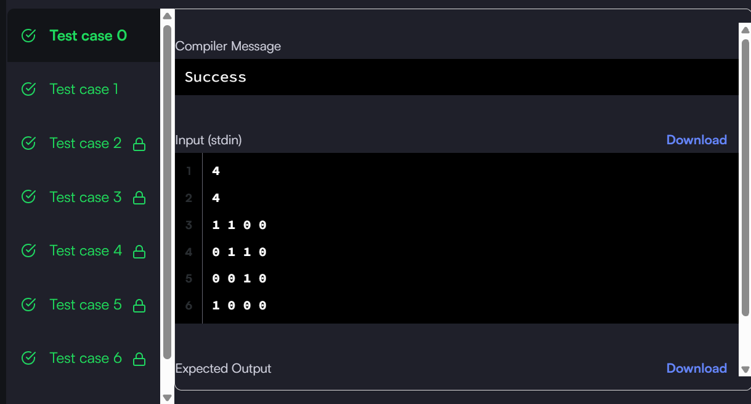

H. Observation:
The problem can be efficiently solved using Depth First Search (DFS).
The important observation is that a cell can be connected to another filled cell in 8 different directions, including diagonals. Whenever an unvisited 1 is encountered, DFS explores the complete region connected to that cell and counts its cells.
By comparing the size of every region, we can determine the largest connected region in the matrix.

